**Test plan:**

A [test plan](https://www.geeksforgeeks.org/software-testing-test-plan-estimates-and-strategy/) is a document that consists of all future testing-related activities. It is prepared at the project level and in general, it defines work products to be tested, how they will be tested, and test type distribution among the testers. Before starting testing there will be a test manager who will be preparing a test plan

**How to create a test plan:**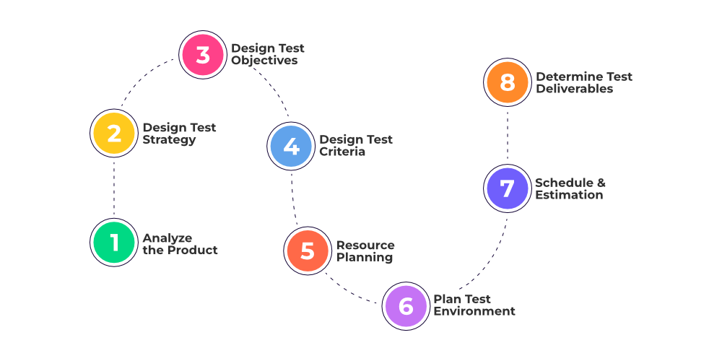

1. **Analyze the product:**This phase focuses on analyzing the product, Interviewing clients, designers, and developers, and performing a product walkthrough.

**2. Design the test strategy:**The test strategy document is prepared by the manager and details the following information:

* Scope of testing
* Type of testing, Risks and issues ,Test logistics

**3. Define test objectives:**This phase defines the objectives and expected results of the test execution. Objectives include:

A list of software features like functionality, GUI, performance standards, etc.

**4. Define test criteria:   
Test criteria** are like rules or standards that help decide if testing is successful. They set clear expectations for what needs to work in the software or system

**5. Resource planning:**This phase aims to create a detailed list of all the resources required for project completion. For example, human effort, hardware and software requirements, all infrastructure needed, etc.

**6. Plan test environment:**This phase is very important as the test environment is where the QAs run their tests. The test environments must be real devices, installed with real browsers and operating systems so that testers can monitor software behavior in real user conditions.

**7. Schedule and Estimation:**Break down the project into smaller tasks and allocate time and effort for each task. This helps in efficient time estimation. Create a schedule to complete these tasks in the designated time with a specific amount of effort.

**8. Determine test deliverables:**Test deliverables refer to the list of documents, tools, and other equipment that must be created, provided, and maintained to support testing activities in the project.

**Test case:**

A **test case** is a detailed set of instructions or conditions that a tester follows to assess if a specific feature, function, or aspect of a software application works as intended. In simple terms:

* It outlines the steps to be taken, the data to be input, and the expected outcomes for a particular test scenario.
* Test cases are designed to verify whether the software behaves correctly under certain conditions and to identify any defects or issues.
* They serve as a systematic way to ensure comprehensive testing coverage and provide a basis for validating the functionality of the software.

1. **Verification:**
   * **Objective:** Verification focuses on checking whether a product or system meets specified requirements and adheres to its design and development specifications.
   * **Activities:** It involves activities such as reviews, inspections, and walkthroughs to identify and address issues in the early stages of development. This includes checking documentation, design, and code against the predefined criteria.
   * **Purpose:** The main goal is to confirm that the work products of each development phase are in compliance with the requirements of that phase. It aims to catch and fix defects early in the development process.
2. **Validation:**
   * **Objective:** Validation is concerned with evaluating a software product during or at the end of the development process to determine whether it satisfies the specified requirements and meets the user's needs.
   * **Activities:** This involves dynamic testing, executing the software to ensure that it behaves as expected. Testing activities such as functional testing, system testing, and acceptance testing fall under validation.
   * **Purpose:** The primary goal is to ensure that the final product meets the customer's expectations and requirements. It focuses on delivering a product that functions correctly and provides value to the end-users.